Hi There.

Thanks for Downloading This Resource.

You Can Edit Your Own Version in One of Two Ways:
- Use this current version here on Google Docs.
- Go to “File” > “Download As” > “Microsoft Word” to Download as a Word Document.

↓↓↓
How to Use These Templates
This document contains eight template prompts for an elevator pitch. Words in [brackets] are meant to be replaced with information about yourself, your company, products, services, and/or customers.

The text that exists outside of the brackets is also meant to serve as a foundation for writing your e-pitch. We encourage you to add, delete, or change any of this copy to ensure your e-pitch matches its intended audience and works with your delivery.

Each template is also accompanied with an example of how it might look when it’s filled out. Feel free to take inspiration from these examples as you choose the best approach for your e-pitch. We even tested reading these aloud ourselves to make sure they could be said in 60 seconds or less.

Once you’re satisfied with your e-pitch, get to memorizing! You never know when you might need to present it to an investor, a potential connection, or a prospect.
Table of Contents
- 4 Investment Opportunity Elevator Pitch Templates
- 2 Networking Opportunity Elevator Pitch Templates
- 2 Sales Opportunity Elevator Pitch Templates

Get a Free CRM for  Your Scaling Business  Learn more about HubSpot’s 100%  free CRM software for your business. | 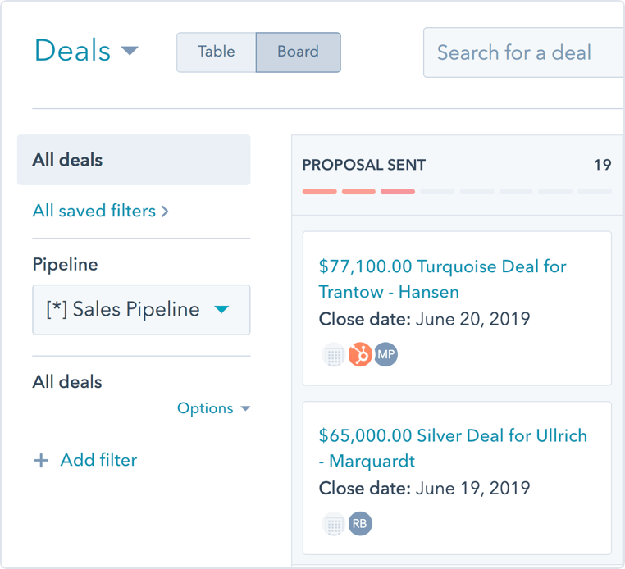
Get Free CRM

(Keep scrolling to templates)
↓

4 Investment Opportunity
Elevator Pitch Templates

Bad-Into-Good E-Pitch Template
Use this prompt when describing a business that turns negative experiences into a positive.

Hello, [audience]. My name is [name], and I am the [role] at [company]. Today, we’re seeking [end goal] in exchange for [offering].

A few years ago, I found myself [explain background scenario]. It was [adjective describing experience]! After that, I knew there needed to be a better way to [activity].

That’s why I developed [product/company name] – a solution to the problems we face when it comes to [topic]. By simply [describe process for using product/service], we’ve eradicated any chance of [negative experience] happening whenever someone tries to [describe activity you’ve fixed].

And with an estimated market size of [number of revenue and/or people in market], we know this will be a successful venture.

I hope you’d be willing to sit down with me and learn more about why this is the perfect opportunity for your portfolio, and how we can help [quantity] of people in the process.

Example

Hello, investors. My name is Juan de la Cruz, and I am the Chief Technology Officer at Traffic Stop. Today, we’re seeking $50,000 in exchange for 10% of our growing company.

A few years ago, I found myself stuck in traffic daily as I commuted from my suburban home to my office job in the city. As you can expect, it was the perfect combination of exhausting and tedious. I knew there needed to be a better way to go to and from work without those traffic-induced headaches.

That’s why I developed Traffic Stop – a solution to the problems we face when it comes to rush hour. By simply identifying backroad solutions, we’ve eradicated any chance of being caught in gridlock when you’re trying to get home to your family after an exhausting day of work.

And with an estimated market size of 50 million daily commuters, we know this will be a successful venture.

I hope you’d be willing to sit down with me and learn more about why this is the perfect opportunity for your portfolio, and how we can help millions of commuters in the process.

Impending Disaster E-Pitch Template
Use this prompt when describing a business that prevents a potential negative outcome.

It’s no secret – [issue] has been plaguing [group/area] for [duration]. Just recently, it was found that [statistic proving your point].

If [issue] remains unaddressed, [explain consequences of inaction]. Luckily, we’re working to fix that.

My name is [name], the [role] of [company] – a solution to [problem] that helps [target market]. Our [product/service/business] [briefly describe what your services accomplish and how].

Not only does [product/service/business name] help [name of cause], it also has the potential to create jobs and revenue. This year, we expect to generate [sales/profit amount] by successfully penetrating the [industry name] market.

But to get there, we’ll need your help – which is why we’re asking for an investment of [amount] as well as your strategic partnership to help us [reiterate positive impact].

Example

It’s no secret – pollution has been plaguing the environment for decades upon decades. Just recently, it was found that by the year 2050, pollution will have an irreversible effect on our planet.

If the destruction of our planet remains unaddressed, Earth may become uninhabitable for future generations. Luckily, we’re working to fix that.

My name is Alexis Matthews, the Founder and President of GloboSave – a solution to pollution that helps remove carbon from the air. Our product removes carbon from the air at a massive scale with our revolutionary and patented technology – drastically lowering the threat of global warming and simultaneously making our air more breathable.

Not only does GloboSave help protect our environment, it also has the potential to create jobs and revenue. This year, we expect to generate $20,000,000 in profit by successfully penetrating the multi-trillion dollar carbon footprint reduction market.

But to get there, we’ll need your help – which is why we’re asking for an investment of $5,000,000 as well as your strategic partnership to help us save the world.

Subject Matter Expertise E-Pitch Template
Use this prompt when describing a business in a domain in which you have obtained subject matter expertise, where personal experience and knowledge makes you sound more credible.

Good [morning/afternoon/evening]. I’m [name], the [role] of [industry] company, [company name]. Over the past [number of years] years, I’ve become an expert in the [industry] field. Between earning my [industry] degree at [university], working as a [role] for [company], and leading [initiative] at [company], I’ve realized one thing about [industry] – [explain realization that led to company founding].

That’s why I’m heading up [company] – the provider of [solution]. By [explain actions taken with product], we’re able to [explain results of using the product]. This product provides a never-before seen solution to [issue].

[Investor name(s)] – I know firsthand that [product/service name] is valuable, speaking on behalf of myself and the [quantity] of other [role types] out there. I’d love your support and guidance to help us get [company] name off the ground, and for an investment of just [amount] in exchange for [offering], I’m confident [company] will be a household name in the [industry] industry. Thank you for your time.

Example

Good evening. I’m Susan Chin, the founder of engineering employee retention company, Enginuity. Over the past twenty years, I’ve become an expert in the engineering field. Between earning my Master’s degree at MIT, working as a solutions architect for Google, and leading engineering at Amazon, I’ve realized one thing about the industry – engineers move fast.

That’s why I’m heading up Enginuity – the provider of engineering-specific employee engagement and retention software. By providing the clarity into performance that both engineers and their managers need, we’re able to pinpoint which engineers are most likely to leave a company and determine how to retain them. This product provides a never-before seen solution to the high engineering turnover rate.

Folks – I know firsthand that Enginuity is valuable, speaking on behalf of myself and the hundreds of thousands of other engineers out there. I’d love your support and guidance to help us get Enginuity name off the ground, and with your investment of just $100,000 in exchange for 20% of the business, I’m confident Enginuity will be a household name in the engineering industry in the next five years. Thank you for your time.
Capitalizing on Demand E-Pitch Template
Use this prompt when describing a business that capitalizes on a growing market segment or opportunity.

My name is [name], I’m here for one reason, and one reason alone – the [market name] market has grown by over [number] percent in the past [number] years.

Since [inciting incident], [number] people have [action taken], which means there has never been a better time for a welcomed innovation in the [market] sector – ever.

That’s why I’m here representing [company name] – a new tool designed specifically to capitalize on the demand for [subject]. Thanks to our patented [technology type], we’ve built a unique solution to [problem] by [explain how solution works].

Here’s the fact – [newfound trend] is here to stay, and we cannot ignore the impact it will have on our lives. For [amount], you’ll help us close our seed round of funding and receive [offering] in the process. Together, we can make [company] the market leader when it comes to [topic].

Example

My name is Jonathan Alexander, I’m here for one reason, and one reason alone – the remote work market has grown by over 10,000 percent in the past two years.

Due to multiple factors – from government stay-at-home orders to a more digitally connected workforce, 24 million people have gone fully or partly remote in the past 24 months, which means there has never been a better time for a welcomed innovation in the remote work sector … ever.

That’s why I’m here representing Remotefriendly – a new tool designed specifically to capitalize on the demand for working remotely. Thanks to our patented software, we’ve built a unique solution to the pains felt by disparate workforces by bringing more coworkers together in a virtual setting for watercoolers, whiteboards, and impromptu meetings.

Here’s the fact – remote work is here to stay, and we cannot ignore the impact it will have on our lives. For $1,000,000, you’ll help us close our seed round of funding and receive 33% of the business in the process. Together, we can make Remotefriendly the market leader when it comes to maintaining office culture in a remote world.

2 Networking Opportunity

Elevator Pitch Templates

Seeking an Opportunity E-Pitch Template
Use this prompt when you’re in front of a person you’d like to work with, work for, or learn more from.

Hello [person’s name] – I know you’re busy, so I’ll keep this brief. My name is [name], and I’m seeking an opportunity to work with you and earn my place in the [industry name] industry.

I’ve long admired your [aspect you respect], and have always wanted to work in [industry]. To get me to where I am today, I’ve [outline actions you’ve taken pertaining to the work you want to do]. This experience taught me [lessons learned].

If you’d be willing to, I’d be so appreciative if we could sit down for [time period] to talk more about my goals and to hear what advice or opportunities you might suggest for someone like me.

Example

Hello Mr. Tarantino – I know you’re busy, so I’ll keep this brief. My name is Esther Rosenblatt, and I’m seeking an opportunity to work with you and earn my place in the entertainment industry.

I’ve long admired your films, and have always wanted to work in the movies. To get me to where I am today, I’ve studied film at USC, competed in my annual local film festivals, and interned at Universal Studios. These experiences have shown me that filmmaking is my life, and I want to spend the rest of it writing stories for the screen just like you have.

If you’d be willing to, I’d be so appreciative if we could sit down for an hour to talk more about my goals and to hear what advice or opportunities you might suggest for someone like me.
Seeking a Partnership, a Consultation, or Resources E-Pitch Template
Use this prompt when you’re pitching to someone you’d like advice or council from.

Good [morning/evening/afternoon], thank you for taking the time to hear me out today. My name is [name] and I am the [title] at [company name].

Would you guess that [surprising statistic]? Well, believe it or not, it’s true – and that’s what I’m going to change with [company name].

I’m currently in the process of developing a solution to [problem], and so far, progress has been amazing. In the last [time frame since starting project], we’ve [outline accomplishments in that time].

I know we’re tapping into a revolutionary solution to the problem of [problem] – and we’re close, but I need your help.

Currently, [company name]’s biggest challenges are [challenge #1], [challenge #2], and [challenge #3]. I need your advice, expertise, and partnership to help me grow [company name] to the heights I know it can achieve. Please let me know if you’d be willing to lend your time and knowledge to learn more about [company name] and help it succeed. Thank you.

Example

Good evening, thank you for taking the time to hear me out today. My name is Jennifer Portle and I am the founder of Weather Buddy.

Would you guess that 80% of people wish they could control the weather? Well, believe it or not, it’s true – and that’s what I’m going to make possible with Weather Buddy.

I’m currently in the process of developing a solution to the inability to control the weather, and so far, progress has been amazing. In the last two years, we’ve identified crucial ways we can weaken the impact of inclement weather.

I know we’re tapping into a revolutionary solution to the problem of weather control – and we’re close, but I need your help.

Currently, Weather Buddy’s biggest challenges are forecasting hurricanes, reversing tornados, and blocking the sunshine. I need your advice, expertise, and partnership to help me grow Weather Buddy to the heights I know it can achieve. Please let me know if you’d be willing to lend your time and knowledge to learn more about Weather Buddy and help it succeed. Thank you!

2 Sales Opportunity

Elevator Pitch Templates

Sales Pitch E-Pitch Template
Use this prompt when you’ve got a minute or less to capture the interest of someone who may be interested in buying your product/service.

Hi [first name] – thanks for taking the time to hear me out.

Let me start off with a question: [question pertaining to the business]?

Well, that’s what we’re trying to do with [company]. In short, we [explain what the company/product does].

The reason we think [product] will be a great fit for you is because [explain benefits for this contact]. We know you [explain action/need of contact], and [product] can help you with that. On average, our customers see [successful performance metric] after using [product].

So let me ask you, is [product] something you’d like to learn some more about?

Example

Hi Jackson – thanks for taking the time to hear me out.

Let me start off with a question: do you have trouble syncing your contacts with your current CRM?

Well, that’s what we’re trying to fix with HubSpot. In short, we unite scaling companies’ contacts throughout all of their marketing, sales, and customer service efforts.

The reason we think HubSpot will be a great fit for you is because we’ve read your company is growing rapidly. We know you need a sustainable solution for all of your teams to connect with your customers, and HubSpot can help you with that. Over 100,000 customers have trusted us to help their companies grow better due to the stronger alignment they gain between their customer-facing teams.

So let me ask you, is HubSpot something you’d like to learn some more about?

Product Pitch E-Pitch Template
Use this prompt when you’re trying to describe your product as succinctly as possible.

The [product name] is a tool that helps [audience] [describe task being accomplished].

It works like this: [explain how product works].

With [product], it’s now possible to [explain unique benefits of using this product].

Without [product], [explain downside(s) of not using the product].

If you want to learn more about [product], [outline steps for learning more about the product].

Example

The Crane Raiser is a tool that helps construction workers and architects operate their cranes more smoothly in a dense city environment.

It works like this: Crane Raiser is an add-on part to any existing crane. It eases the typically rigid operation of handling a crane and lessens the impact of more jarring motions – increasing the safety of construction workers and the people and infrastructure in the surrounding environment.

With Crane Raiser, it’s now possible to get construction work done faster, and more importantly, safer.

Without Crane Raiser, construction companies keep the existing risk of high insurance claims, injury to workers, and running behind schedule on crucial jobs.

If you want to learn more about Crane Raiser, visit us on our website, where you can book time with me to discuss buying Crane Raiser for your business.

